Project Design Phase - I Solution Architecture

|  |  |
| --- | --- |
| Date | 10 October 2022 |
| Team ID | PNT2022TMID12127 |
| Project Name | Smart Farmer-IoT Enabled Smart Farming Application |
| Maximum Marks | 4 Marks |

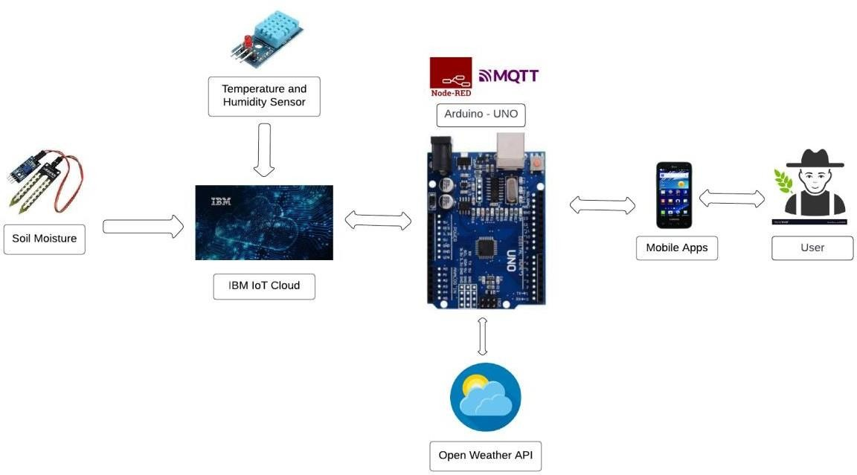

* The different soil parameters (temperature, humidity, Soil Moisture) are sensed using different sensors, and the obtained value is stored in the IBM cloud.
* Arduino UNO is used as a processing unit that processes the data obtained from sensors and weather data from weather API.
* Node-red is used as a programming tool to wire the hardware, software, and APIs. The MQTT protocol is followed for communication.
* All the collected data are provided to the user through a mobile application that was developed using the MIT app inventor. The user could make a decision through an app, whether to water the crop or not depending upon the sensor values. By using the app, they can remotely operate the motor switch.